SUBCOURSE EDITION
AV 0653 B

US ARMY AVIATION CENTER

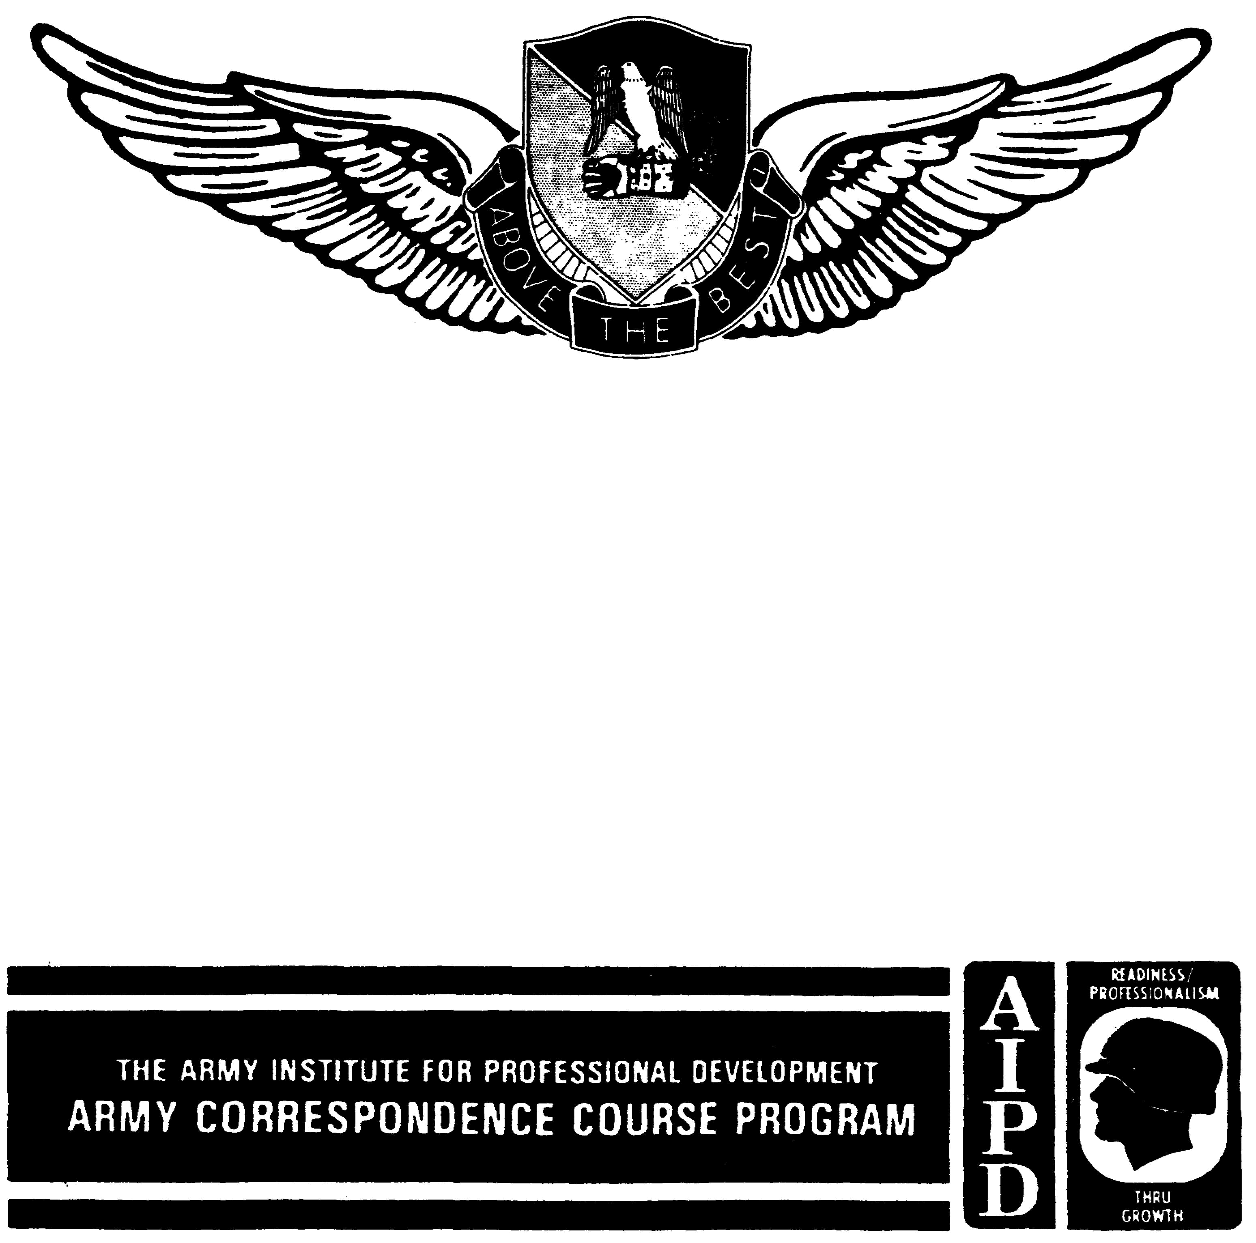

MILITARY AIRCRAFT DESIGNATION
SYMBOLS

THIS SUBCOURSE HAS BEEN REVIEWED FOR
OPERATIONS SECURITY CONSIDERATIONS.

MILITARY AIRCRAFT DESIGNATION SYMBOLS

Subcourse Number AV 0653

EDITION B

United States Army Aviation Center
Fort Rucker, Alabama 36362-5255

3 Credit Hours

Edition Date: March 1993

SUBCOURSE OVERVIEW

This subcourse gives the user (MOS 93C and 93P) a working knowledge of military aircraft designation symbols (aircraft types and uses) and military branch of service and military mission prefixes (radio identifications) used to communicate with military aircraft.

No prerequisites exist for this subcourse.

This subcourse reflects the current doctrine when it was prepared. In your own work, always refer to the latest publications.

Unless otherwise stated, the masculine gender of singular pronouns refers to men and women.

TERMINAL LEARNING OBJECTIVE

ACTION: You will identify basic mission symbols, type of aircraft symbols, and design numbers and decode branch of service and military mission prefixes.

CONDITION: You will use the material in this subcourse.

STANDARD: To prove competency of this task, you must achieve a minimum of 70 percent on the examination.

AV 0653

TABLE OF CONTENTS

Section Page

Lesson 1: Military Aircraft Designation Symbols 1-1

Definitions 1-1
Military Designation Symbols 1-2

Practice Exercise 1-7

Answer Key and Feedback 1-9

Lesson 2: Military Aircraft Service and Mission
Prefixes 2-1

Military Aircraft Service Prefix 2-2
Military Mission Prefix 2-3

Practice Exercise 2-5

Answer Key and Feedback 2-7

i AV 0653

LESSON 1

MILITARY AIRCRAFT DESIGNATION SYMBOLS

Critical Task: 011-144-1022

OVERVIEW

LESSON DESCRIPTION:

In this lesson you will learn to decode military aircraft designation symbols.

TERMINAL LEARNING OBJECTIVE:

ACTION: Decode military aircraft designation symbols.

CONDITION: While on duty in an air traffic control facility or in flight operations (airport operations area) and given written or verbal military designation symbols.

STANDARD: You will decode military aircraft designation symbols correctly according to AR 70-50.

REFERENCE: The material in this lesson was derived from the following publications: AR 70-50 and FAR Part 1.

INTRODUCTION

This lesson presents a list of Army aircraft designation symbols. You will learn to recognize the different types of Army aircraft and their basic and modified uses without actually seeing the aircraft indicated. The letters and numbers will provide enough information to determine if the aircraft is a helicopter or an airplane and what is its use to the Army.

1. DEFINITIONS

In order to begin to understand military aircraft designation symbols, you must first understand the definitions of certain words. The definitions of those words, according to federal aviation regulation (FAR) Part 1, are as follows:

a. An aircraft is a device that is used or intended to be used for flight in the air.

1-1 AV 0653

b. An airplane is an engine driven, fixed-wing aircraft that is heavier than air. It is supported in flight by the dynamic reaction of the air against its wings (lift).

c. A helicopter is a rotorcraft that, for its lift and horizontal motion, depends principally on its engine-driven rotors.

2. MILITARY DESIGNATION SYMBOLS

a. Basic Mission and/or Type Symbol. This symbol (Table 1-1) identifies an aircraft's primary function and capability. You may use any one of these basic mission symbols and/or type symbols alone with a design number to indicate a military aircraft as explained in Figure 1-1, (page 1-4).

NOTE: Read ALL the information in Table 1-1.

b. Design Number. The design number refers to the sequence number of each major design (or model) change within the same mission category. Design numbers run consecutively. The numeral "1" is used to begin each category.

EXAMPLE: OV-1

NOTE: A dash (-) is used to separate the design number from the symbol to its immediate left.

c. Modified Mission Symbol. This symbol is (Table 1-2, page 1-4) used to identify modifications to the basic mission of an aircraft. Only one modified mission symbol should be used in any one military designation symbol. By starting with the basic type symbol H, add the modified mission symbol A and the design number 64. The result is AH-64. You now have a helicopter modified for attack missions.

EXAMPLE: AH-64

NOTES: You may have noticed this lesson is not designed to examine the military designation symbol from left to right as you would read the English language! It is designed in an easy to understand learning method.
Read ALL the information in Table 1-2.

d. Status Prefix Symbols. This symbol (Table 1-3, page 1-5) is used only when necessary to indicate that an aircraft's test, modification, and experimental or prototype design do not make it a standard vehicle.

EXAMPLE: YAH-64

NOTE: Read ALL the information in Table 1-3.

1-2 AV 0653

Table 1-1. Basic mission and/or type symbols

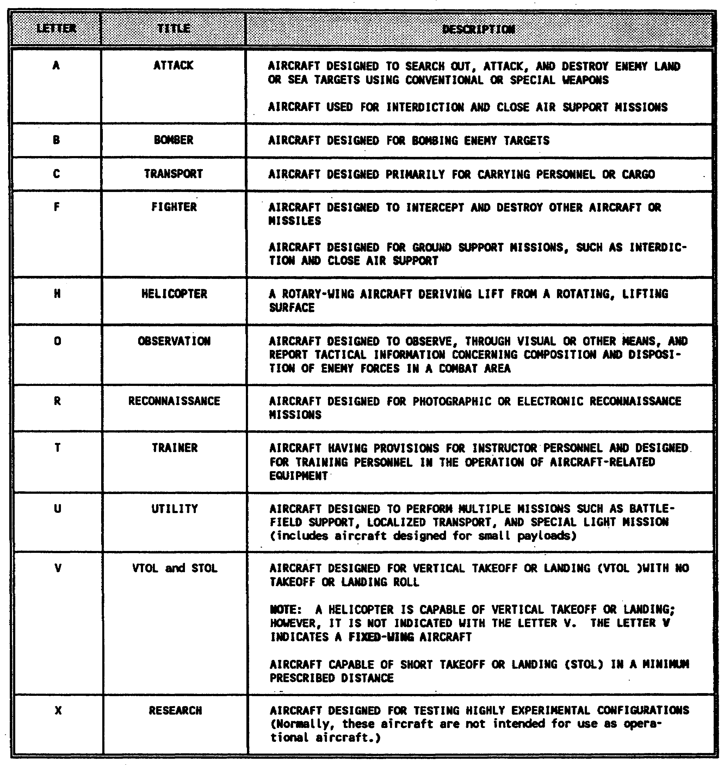

e. series. This symbol identifies the first production model of a particular design and any subsequent models representing major modifications. Consecutive series symbols start with the letter A and are placed to the immediate right of the design number.

1-3 AV 0653

EXAMPLE: OH-58A

NOTES: To avoid confusion, the letters I and O are not used for this symbol.
A complete example is shown in Figure 1-2, page 1-6.

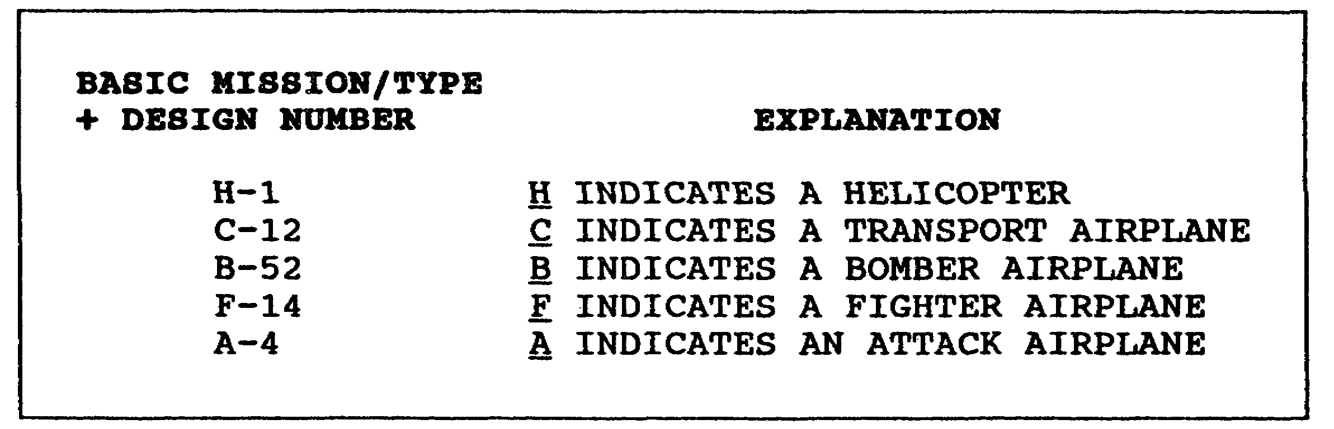

Figure 1-1. Basic mission and/or type symbol explanation

Table 1-2. Modified mission symbols

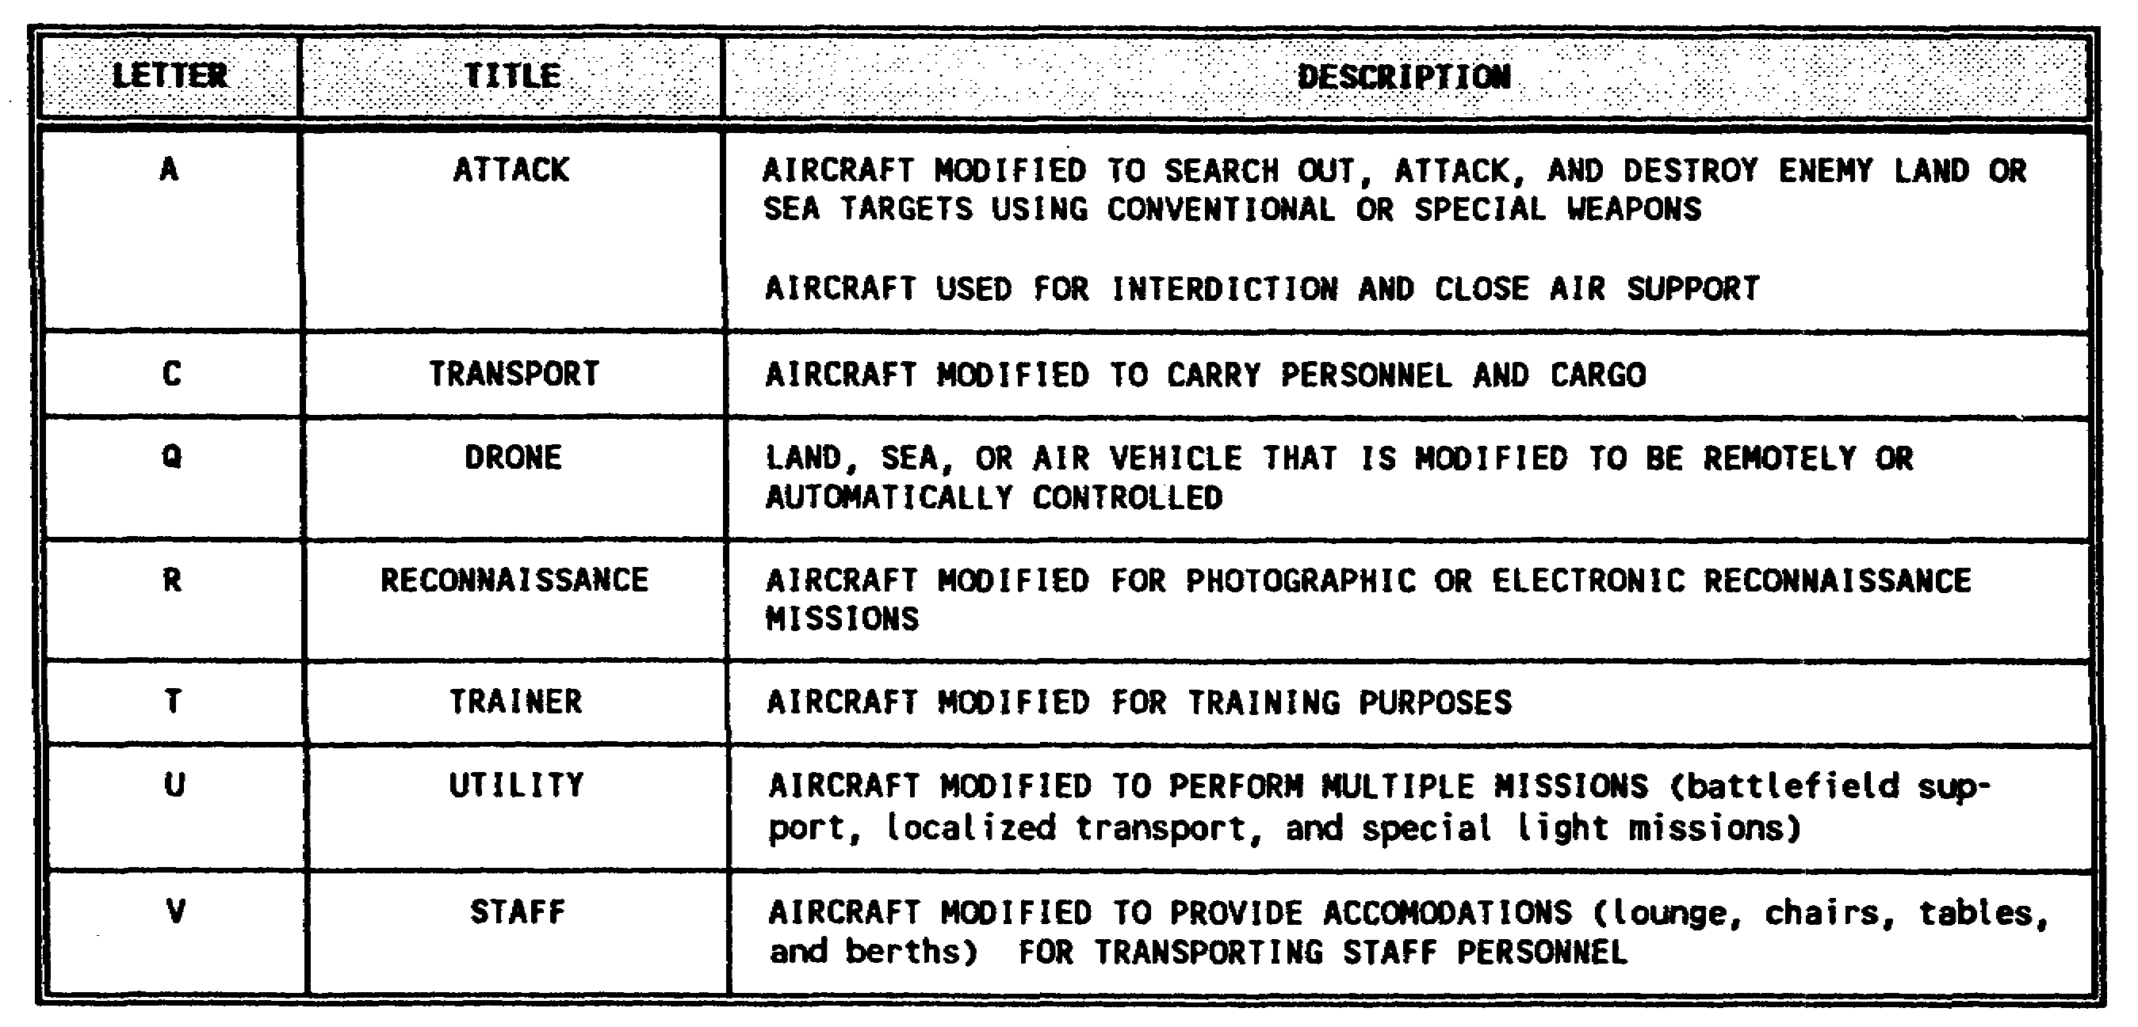

1-4 AV 0653

Table 1-3. Status prefix symbols

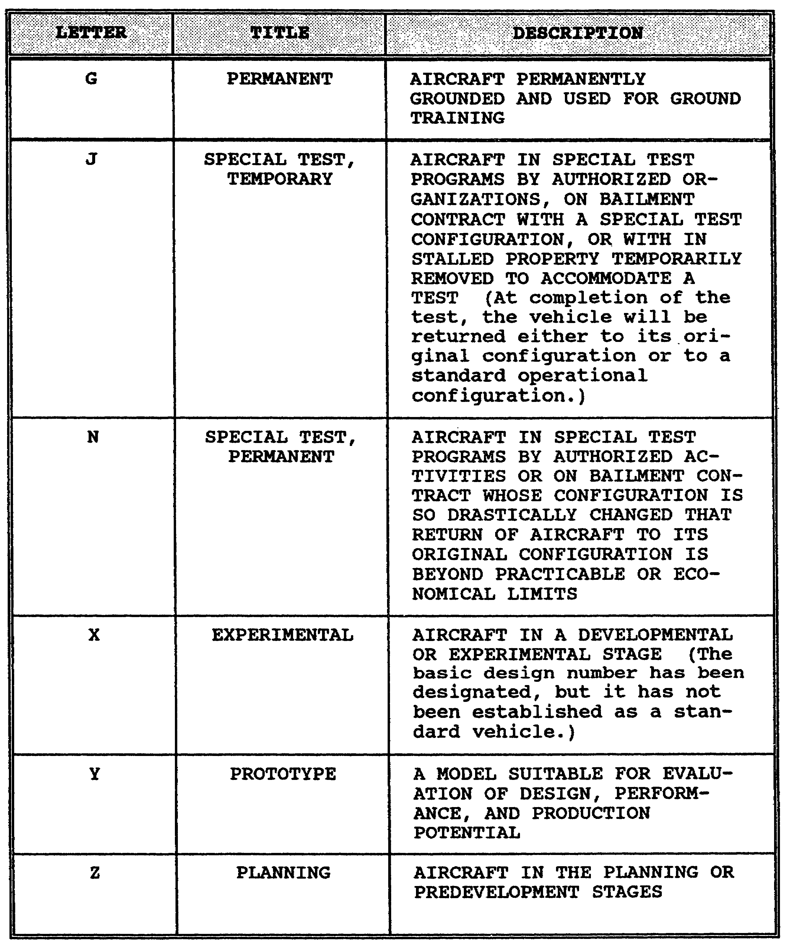

1-5 AV 0653

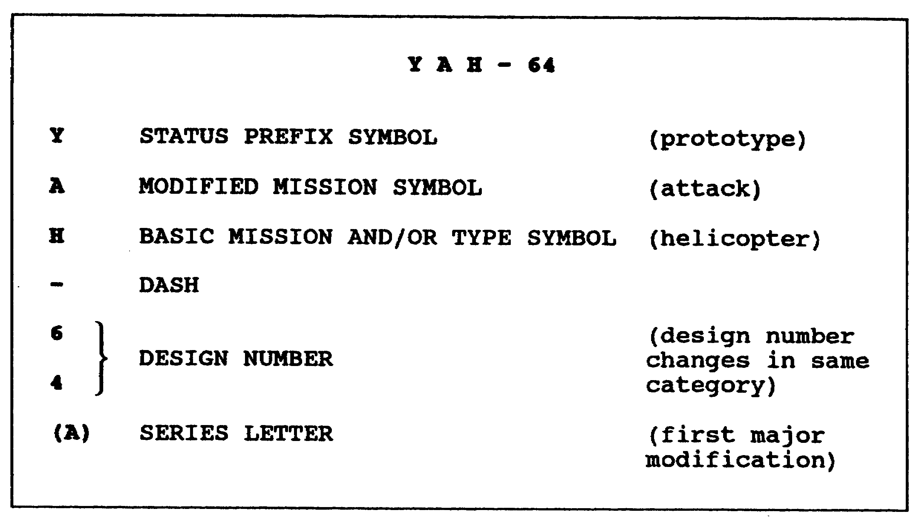

Figure 1-2. Military designation symbols and number
explanation

1-6 AV 0653

LESSON 1

PRACTICE EXERCISE

The following items will test your grasp of the lesson material. Each item has only one correct answer. When you complete the exercise, check your answers with the answer key that follows. If you answer any item incorrectly, restudy that part of the lesson.

1. An aircraft that is permanently grounded and used for ground training would have what status prefix symbol?

A. G
B. Q
C. X
D. Z

2. What does the letter "V" in the observation aircraft OV-1 indicate?

A. aircraft capable of STOL
B. very short takeoff aircraft
C. vertical helicopter operations
D. short aircraft and all helicopters

REQUIREMENT: For items 3 through 5, write the letter that represents the series symbol.

3. CH-47A ______

4. CH-47B ______

5. AH-1G ______

REQUIREMENT: For items 6 through 15, write in the basic mission and/or type symbol and the modified mission symbol.

6. B-52

7. C-12

8. OH-58 ,

9. F-14

10. U-21

1-7 AV 0653

11. AH-1 ,

12. C-130

13. A-4

14. TH-1 ,

15. CH-47 ,

REQUIREMENT: For items 16 through 19, write in the name each letter or number represents.

 |  |  |  |  | U | H | - | 6 0 | A
 |  |  |  |  | ↑ | ↑ |  | ↑ | ↑
16.
17.
18.
19.

1-8 AV 0653

LESSON 1

PRACTICE EXERCISE

ANSWER KEY AND FEEDBACK

Item Correct Answer and Feedback

1. A. G

The letter G represents the status prefix for an aircraft that is permanently grounded. (page 1-5, Table 1-3)

2. A. aircraft capable of STOL.

This is a fixed-wing aircraft capable of STOL and is used as an observation aircraft. (page 1- 3, Table 1-1)

3. A

The series symbol identifies a particular design of aircraft (model) that has had a major modification. (page 1-3, para 2e)

4. B

The series symbol identifies a particular design of aircraft (model) that has had a major modification. (page 1-3, para 2e)

5. G

The series symbol identifies a particular design of aircraft (model) that has had a major modification. (page 1-3, para 2e)

6. bomber.

The basic mission is to carry bombs. (page 3, Table 1-1)

7. transport.

The basic mission is to transport cargo, personnel, or both. (page 1- 3, Table 1-1)

1-9 AV 0653

Item Correct Answer and Feedback

8. observation, helicopter.

The basic mission is for visual observation of enemy forces; the type aircraft is a helicopter. (page 1-3, Table 1-1)

9. fighter.

The basic mission is to intercept and destroy other aircraft. (page 1-3, Table 1-1)

10. utility.

The basic mission is for battlefield support. (page 1-3, Table 1-1)

11. attack, helicopter.

The basic mission is to attack land or sea targets and for close air support; the type aircraft is a helicopter. (page 1-3, Table 1-1)

12. transport.

The basic mission is to transport cargo, personnel, or both. (page 1-3, Table 1-1)

13. attack.

The basic mission is to attack land or sea targets and for close air support. (page 1-3, Table 1-1)

14. trainer, helicopter.

The basic mission is for training personnel to operate the aircraft; the type aircraft is a helicopter. (page 1-3, Table 1-1)

15. transport, helicopter.

The basic mission is to transport cargo, personnel, or both; the type aircraft is a helicopter. (page 1-3, Table 1-1)

16. utility

According to AR 70-50 this is the only correct answer for the modified mission symbol. (page 1-2, para 2b; page 1-3, Table 1-1; and page 1-4, Table 1-2)

1-10 AV 0653

Item Correct Answer and Feedback

17. helicopter

According to AR 70-50 this is the only correct answer for the basic mission or type symbol. (page 1-3, Table 1-1, and page 1-2, para 2a)

18. design number

According to AR 70-50 this is the only correct answer. (page 1-2, para 2b)

19. first major modification

According to AR 70-50 this is the only correct answer for this series letter. (page 1-3, para 2e)

1-11 AV 0653

LESSON 2

MILITARY AIRCRAFT SERVICE AND MISSION PREFIXES

Critical Task: 011-144-1022

OVERVIEW

LESSON DESCRIPTION:

In this lesson you will learn to decode military aircraft-service and mission prefixes.

TERMINAL LEARNING OBJECTIVE:

ACTION: Decode military aircraft service and mission prefixes.

CONDITION: You will use the lesson text to complete the action.

STANDARD:

CONDITION: While on duty in an air traffic control (ATC) facility or in flight operations (airport operations area) and given written or verbal military aircraft service and mission prefixes.

STANDARD: You will decode military aircraft service and mission prefixes correctly according to FAA Handbook 7110.65.

REFERENCE: The material in this lesson was derived from the following publication: FAA Handbook 7110.65.

INTRODUCTION

This lesson presents a list of military aircraft service and mission prefixes. You will learn to recognize these letters and numbers as a radio identification used in two-way communication with military aircraft.

2-1 AV 0653

1. MILITARY AIRCRAFT SERVICE PREFIX

This prefix (Table 2-1) is the military service name, coded to a letter, indicating the branch of service. It is followed by the last five numbers of the aircraft serial number.

EXAMPLE: R12345.

NOTE: Read all the information in Table 2-1.

Table 2-1. Branch of service prefix

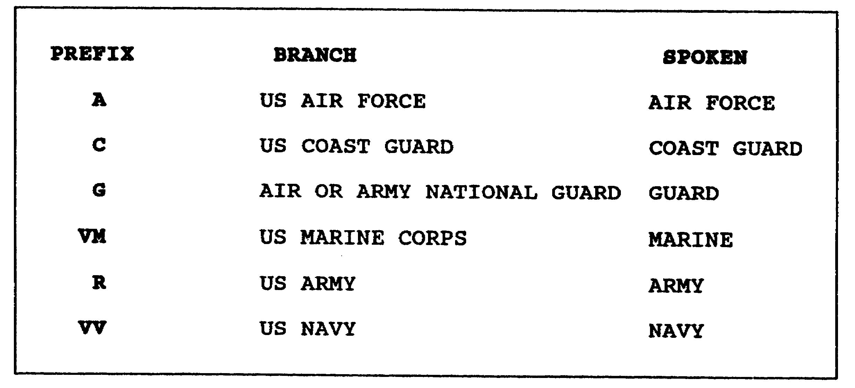

a. Maintaining radio contact and positive control of military aircraft is a necessity for ATC and many military missions. The previous example would be written as shown and interpreted as an Army aircraft with the last five numbers of its serial number. During aircraft flight planning and en route and terminal stages of the flight or military mission, R12345 would be spoken "Army one-two-three-four-five" when using two-way radio communications.

b. Consider each prefix from Table 2-1 and add five numbers that could be serial numbers of aircraft. You will then have a military aircraft service prefix or identity.

EXAMPLE: VV13492 is a Navy aircraft with the last five of its serial numbers listed. It would be identified in two-way radio communications as "Navy one-three-four-niner-two."

2-2 AV 0653

2. MILITARY MISSION PREFIX

This is the military mission prefix, coded to a letter (Table 2-2), indicating the type of mission the military aircraft is involved with. It is also followed by the last five numbers of the aircraft's serial number.

EXAMPLE: E12345

NOTE: Read all the information in Table 2-2.

Table 2-2. Military mission prefix

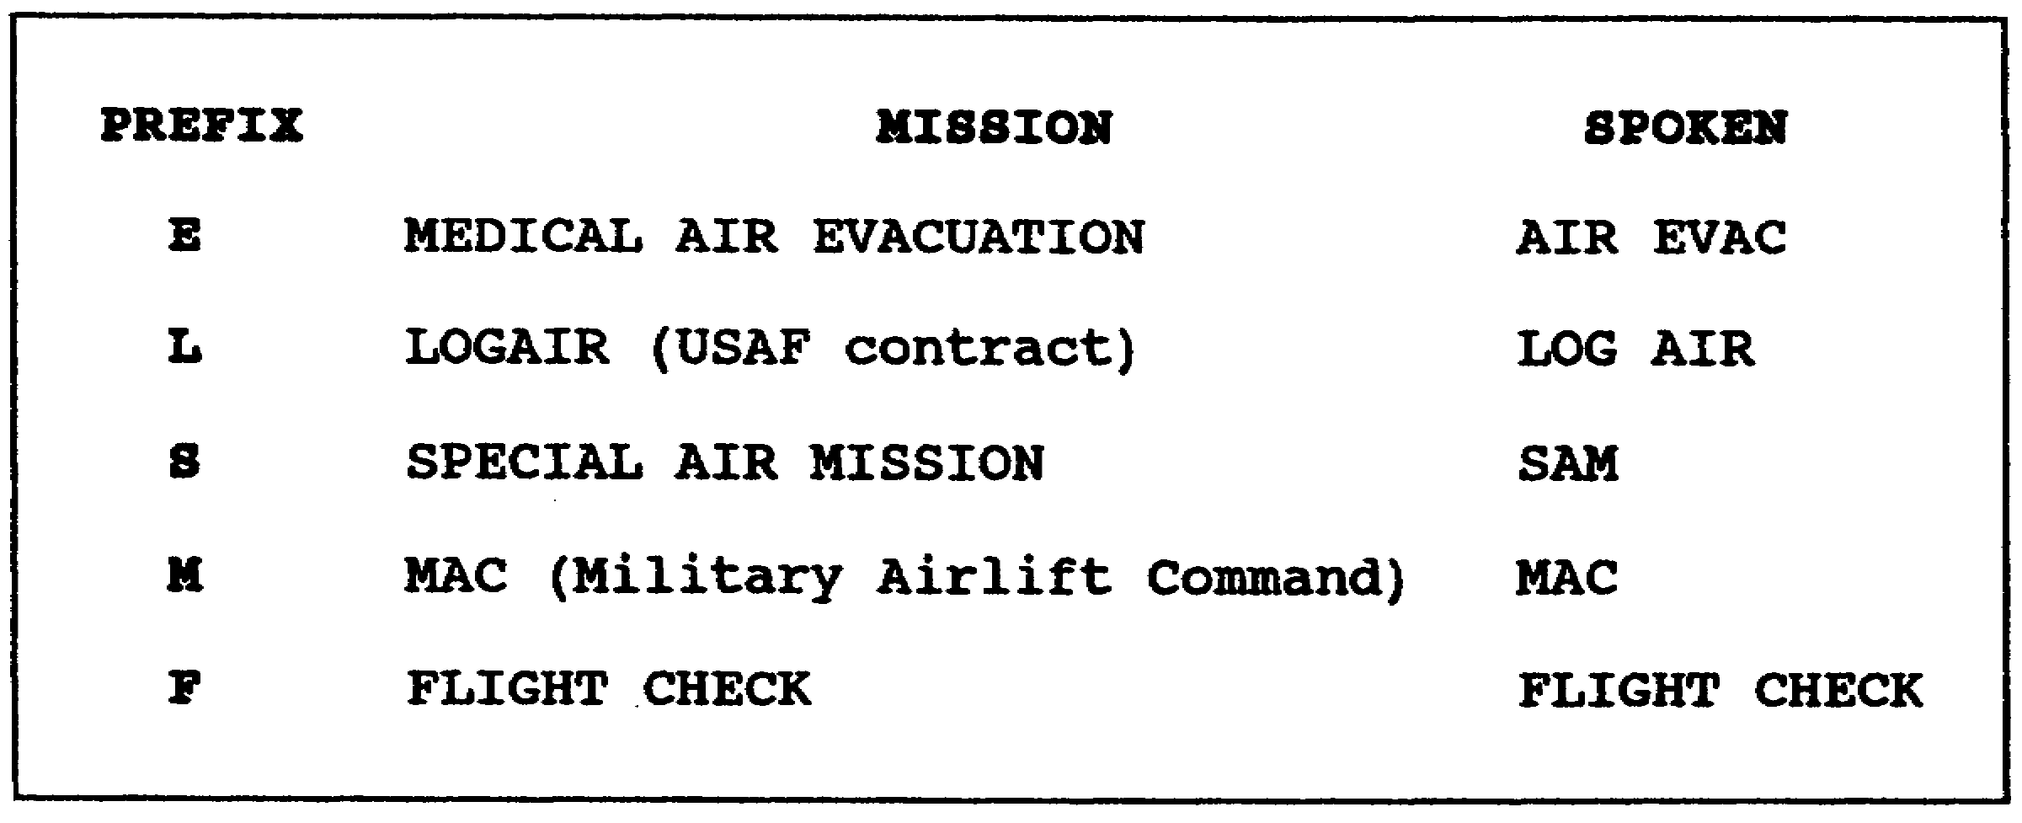

a. This information is used in the same way the military aircraft service prefix is used. The previous example would be written as shown and interpreted as a medical air evacuation aircraft with the last five numbers of its serial number. During aircraft flight planning and en route and terminal stages of the flight or military mission, E12345 would be spoken "AIR EVAC one-two-three-four-five."

b. Consider each prefix from Table 2-2 and add five numbers that could be serial numbers of aircraft. You will then have a military mission prefix or identity.

EXAMPLE: M31974 is an aircraft belonging to the US Air Force Military Airlift Command with the last five of its serial numbers listed and identified in two-way radio communications as "MAC three-one-niner-seven-four."

2-3 AV 0653

LESSON 2

PRACTICE EXERCISE

The following items will test your grasp of the lesson material. Each item has only one correct answer. When you complete the exercise, check your answers with the answer key that follows. If you answer any item incorrectly, restudy that part of the lesson.

1. The branch of service prefix G indicates

A. US Coast Guard.
B. German Air Corps.
C. Canadian Coast Guard.
D. US Air or Army National Guard.

2. Which military mission prefix and serial numbers would indicate an AIR EVAC aircraft?

A. E14192
B. M20114
C. A21359
D. S35297

3. A military branch of service or military mission prefix with an aircraft serial number would be used by air traffic controllers and flight operations specialists for

A. aircraft recognition.
B. observing an air show.
C. identifying different types of aircraft.
D. two-way radio communication with aircraft.

4. The military mission prefix S indicates an aircraft being used

A. for a flight check.
B. for a special air mission.
C. for medical air evacuation.
D. by the military airlift command.

REQUIREMENT: For items 5 through 9, decode the military service prefixes.

5. R13497 = one-three-four-niner-seven

6. A41799 = four-one-seven-niner-niner

2-5 AV 0653

7. C71223 = seven-one-two-two-three

8. VV21568 = two-one-five-six-eight

9. VM13725 = one-three-seven-two-five

2-6 AV 0653

LESSON 2

PRACTICE EXERCISE

ANSWER KEY AND FEEDBACK

Item Correct Answer and Feedback

1. D. US Air or Army National Guard.

According to FAA Handbook 7110.65, this is the only correct answer. (page 2-2, Table 2-1)

2. A. E14192

According to FAA Handbook 7110.65, this is the only correct answer. (page 2-3, Table 2-2)

3. D. two-way radio communication with aircraft.

According to FAA Handbook 7110.65, this is the only correct answer. (page 2-1, INTRODUCTION; page 2-2, para la; and page 2-3, para 2a)

4. B. for a special air mission.

The letter S followed by the last five numbers of the aircraft's serial number (S11438) is spoken as "SAM one-one-four-three-eight."

According to FAA Handbook 7110.65, this is the only correct answer. (page 2-3, Table 2-2)

5. Army

According to FAA Handbook 7110.65, this is the only correct answer. (page 2-2, Table 2-1)

6. Air Force

According to FAA Handbook 7110.65, this is the only correct answer. (page 2-2, Table 2-1)

2-7 AV 0653

Item Correct Answer and Feedback

7. Coast Guard

According to FAA Handbook 7110.65, this is the only correct answer. (page 2-2, Table 2-1)

8. Navy

According to FAA Handbook 7110.65, this is the only correct answer. (page 2-2, Table 2-1)

9. Marine

According to FAA Handbook 7110.65, this is the only correct answer. (page 2-2, Table 2-1)

2-8 AV 0653

